**Third Year B. Tech., Sem VI 2021-22 Software Engineering Tools Lab Assignment Submission**

Assignment No-2

Topic :Google Colab

**Batch :T2**

Students 2019BTECS00074

2019BTECS00075

1. Original author

Ans : Google collab is product of Google Research

1. Developers

Ans : Google developers team developed google collab

1. Initial release:

Ans: 2014

1. Stable release Ans: 2017
2. Preview release Ans: 2014
3. Repository (with cloud support )

Ans: <https://github.com/googlecolab>

1. Written in (Languages) Ans : Python
2. Operating System support

Ans: Windows, Linux distributions, MAC

1. Platform ,portability

Ans: Web, yes it is portable

1. Available in (Total languages)

Ans: 40 languages including python,R,scala,julia etc…

1. List of languages supported

Ans: python,R,scala,julia and even more

1. Type (Programming tool, integrated development environment etc.) Ans: It is Notebook environment for collaborative development
2. Website

Ans: <https://colab.research.google.com/>

1. Features

Ans: Interactive tutorials to learn machine learning and neural networks Execute terminal commands from notebook

Import datasets from external sources Free cloud services, GPUs and TPUs

1. Size (in MB, GB etc.) Ans: 12.7 GB
2. Privacy and Security

Ans: It is secure as it is our private google document and no one can access it

1. Type of software (Open source/Licence)

Ans: Open source

1. If Licence- Provide details.

Ans:

1. Latest version Ans:
2. Cloud support (Yes/No) Ans: yes
3. Applicability

Ans: To develop collaborative softwares or programs

1. Drawbacks (if any) Ans:

Question 2 -

Downloading Given Data Set -

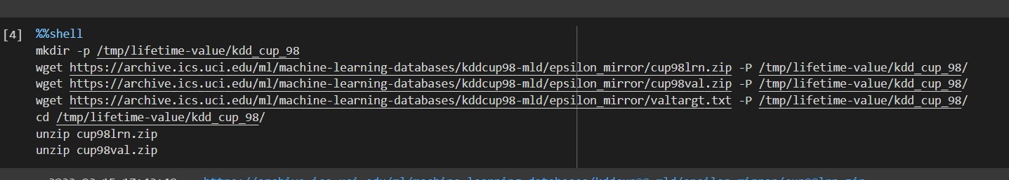

Output of Regression ( Donations And Count )

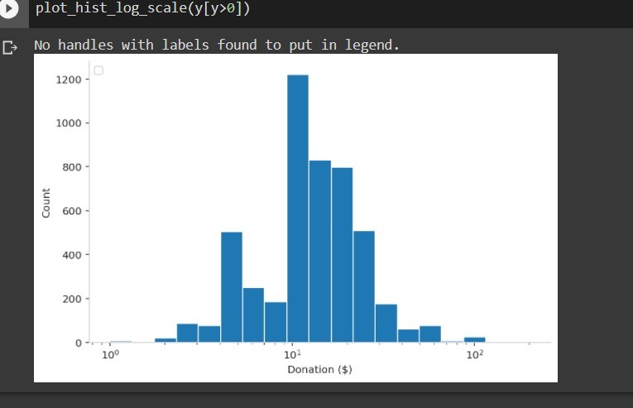

Training Data -

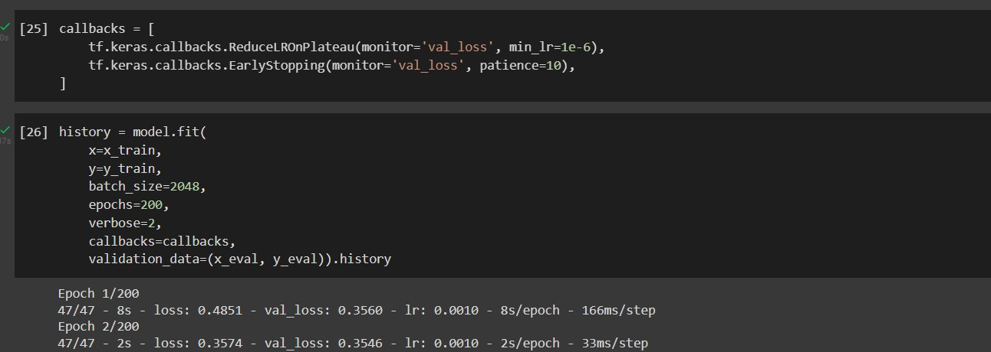

Total Profit -

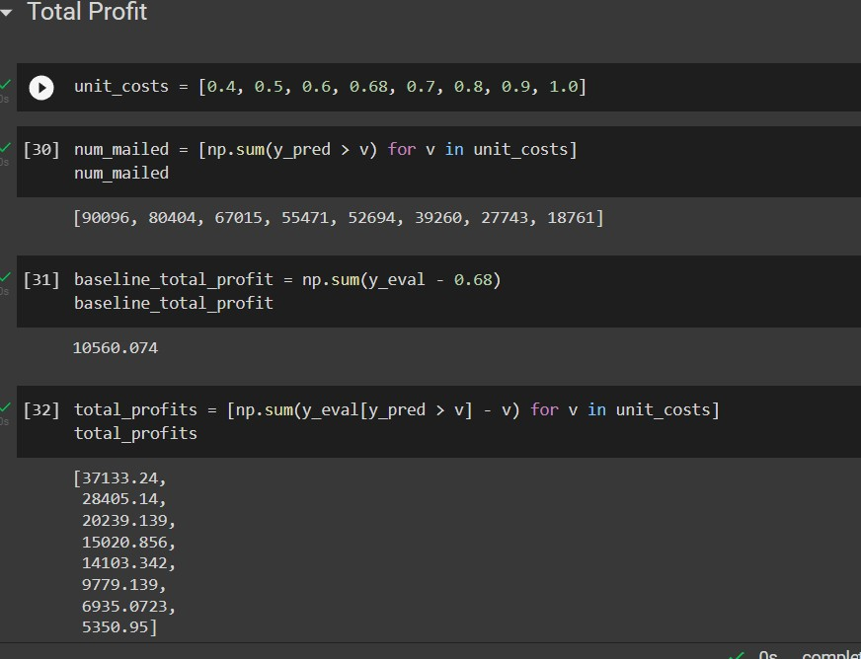

Loss Graph -

